Group Selection 2

You can place all these snippets of code for problems 1, 2 and 3 in the same vb file. I would recommend that you write one, make sure that it works, comment it and then move on to the next problem.

m2)

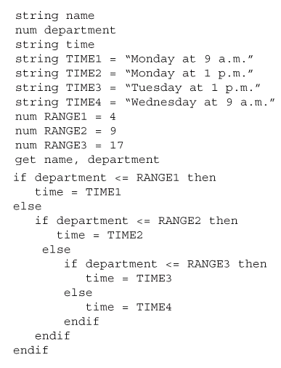 | 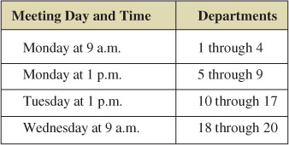

Given the above code, rewrite the above structure such that it compares in descending as opposed to ascending order. In other words, instead of starting the comparison structure from the lowest department range (1-4), start from the highest (18-20) and move to the lowest.

3) Write the VB program for the following. The Dorian Gray Portrait Studio charges its customers for portrait sittings based on the number of subjects posing for the portrait along with the day on which the portrait is taken.

The fee schedule is as follows:

Subjects in Portrait | Base Price
1 | $100
2 | $130
3 | $150
4 | $165
Otherwise | Use the random number generator to generate a number between 200 and 300
(Use a select/case structure for determining the base price for the number of subjects in the portrait)

- Add an extra 20 percent more to the base price if portrait sitting occurs on Saturday or Sunday. (Use if/else. Use the AND operator)

- Deduct 10% from the base price if portrait sitting occurs on Mondays and there are 3 subjects in the portrait. (Use if/else. Use the OR operator)

- Deduct 15% from the base price if portrait sitting occurs on Tuesdays and there are 4 subjects in the portrait. (Use if/else. Do not use the AND operator. Do not use the OR operator. Use nested if statements.)

What to turn in:
  - One VB source file
Make sure to rename the extension from .vb to .txt

